Student Name: Xianglong Lin Student Number: 45791439 Team Name: H2OMG
Week: _9_
Title: Balancing User Experience and Technical Performance through User Enactment
Description:
In the 9th week, I conducted user enactment in the studio to simulate the interaction between users and the water conservation system in real-life scenarios. According to the high-fidelity prototype of last week, I designed a scenario where a university student controlled the duration of water usage through the water system during the shower. The device utilised the water flow tracking feature enabled to users, allowing users to customise their water usage and receive real-time water usage reminders through the lights (Green: Normal; Yellow: Critical Value; Red: Overused) to limit usage and receive suggestions for reducing shower time. This user enactment vividly demonstrated the assessment of the intuitive nature of notifications and their effectiveness in guiding users to make real-time water-saving responses and actions. In addition, during the mid-semester break, I hosted the group meeting to determine the important guidelines for using HTML, CSS, and JavaScript as the front-end development programming language for the website.
Visual Evidence:
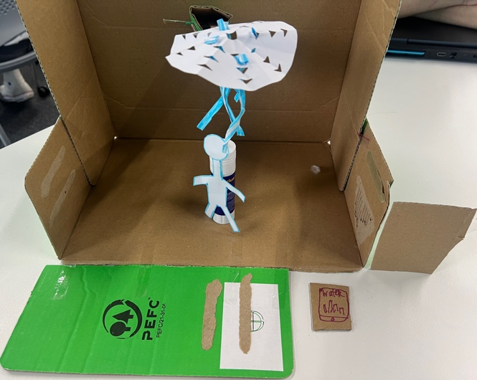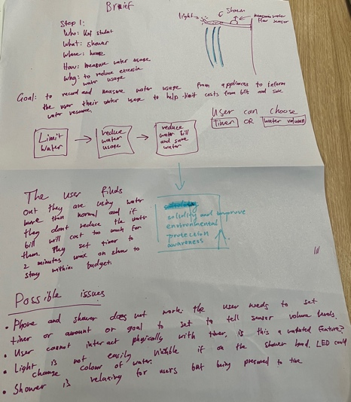
Statement on Learning:
The interesting team task of user enactment in this studio not only built user scenarios, but also highlighted the pertinence and importance of simulating user behaviour to improve the user experience, especially the management of water resources during the shower process, even though the equipment and system were suitable for various water use scenarios. Although the high-fidelity prototype last week was able to detect and provide real-time data well, this simulation revealed that there was still room for improvement in notifications to ensure the system was intuitive and user-friendly. For example, it was a bit challenging to ensure that the lights were placed in a prominent position to remind users about water usage while also avoiding contact with water as much as possible.
Unlike last week's focus on technical functions, this user enactment reflected the necessity and importance of user experience. The prompts and notifications should be simple and applicable, so that users could notice as soon as possible. For example, when the green light turns to yellow, users will know how long it will take for the water usage they have set to reach the limit. However, it is not practical to display a prompt pop-up only on devices such as users' mobile phones, as most people will avoid bringing their phones into the shower.
This user enactment emphasised the balance between technical performance and user experience. Real-time notifications assist users in making water-saving measures, but meanwhile, ensuring that the notifications are contextually appropriate and motivating is a top priority, so that the users’ sense of accomplishment in approaching the established water-saving goals enhances the users’ psycho-pleasure, as mentioned by last studio. This discovery also prompted us to prioritise developing web-based systems using HTML, CSS, and JavaScript, which are simple and easy to implement not only in terms of user interface but also in terms of programming and development difficulty, rather than building mobile applications.

